9th CBSE Science Chitkara International School
Student Name:_______________________________________________ Roll. No._____________________________
General Instructions :
i. This question paper consists of 39 questions in 5 sections.
ii. All questions are compulsory. However, an internal choice is provided in some questions.
A student is expected to attempt only one of these questions.
iii. Section A consists of 20 objective type questions carrying 1 mark each.
iv. Section B consists of 6 very Short Answer type questions carrying 02 marks each.
Answers to these questions should be in the range of 30 to 50 words.
v. Section C consists of 7 Short Answer type questions carrying 03 marks each.
Answers to these questions should be in the range of 50 to 80 words.
vi. Section D consists of Long Answer type questions carrying 05 marks each. Answers to these questions should be in the range of 80 to 120 words
vii. Section E consists of 3 source-based/case-based units of assessment of 04 marks each with sub-parts.
SECTION -A
(Select and write the most appropriate option out of the four options given for each of the
questions 1-20)
- A student is asked to make a homogeneous mixture. He is provided with the following substances.
A. Water B. Soil C. Oil D. Chalk powder E. Salt
Which two substances should the student mix to form a homogeneous mixture?
(a) A and B (b) C and D (c) B and E (d) A and E
- Which of the following will show the "Tyndall effect"?
(a) Salt solution (b) Sugar solution
(c) Milk solution (d) Copper sulphate solution
- Which of the following are chemical changes?
(i) Decaying of wood (ii) Burning of wood (iii) Sawing of wood
(iv) Hammering of a nail into a piece of wood
(a) (i) and (ii) (b) (ii) and (iii) (c) (iii) and (iv) (d) (i) and (iv)
- Two atoms are said to be isotopes if ……………….. .
(a) they have same atomic number, but different mass number
(b) they have same number of electrons, but different number of protons.
(c) they have the same number of neutrons, but different numbers of electrons.
(d) both (a) and (b)
- Two substances, A and B, react to form a third substance, A2B, according to the following reaction:
2A+B→A2B
Which of the following statements concerning this reaction are not correct?
(i) The product A₂B shows the properties of substances A and B.
(ii) The product will always have a fixed composition.
(iii) The product so formed cannot be classified as a compound.
(iv) The product so formed is an element.
(a) (i) and (iii) (b) (ii) and (iv) (c) (iii) and (iv) (d) (i) and (ii)
- Which of the following does not represent Bohr's model of an atom correctly?
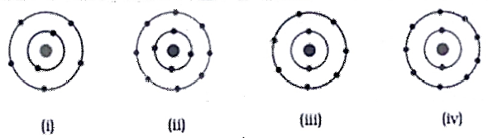
(a) (i) and (ii) (b) (ii) and (iii) (c) (ii) and (iv) (d) (i) and (iv)
- Select the correct relation between atomic number, mass number and number of neutrons.
(a) Mass number = atomic number + number of neutrons
(b) Mass number = atomic number/number of neutrons
(c) Mass number =atomic number × number of neutrons
(d) Mass number = atomic number - number of neutrons
- A goalkeeper in a football game pulls his hands backwards after holding the ball shot at the goal. This enables the goalkeeper to ……………… .
(a) increase the rate of change of momentum
(b) decrease the rate of change of momentum
(c) increase the force exerted by the balls on the hands
(d) exert larger force on the ball
- A mass is moving with a speed of 5m/s along the x-direction on a smooth surface, when a force of
5N acts on it along the y-axis. The work done by the force is
(a) 25J (b) 10 J (c) Depends on time (d) Zero
- When a body vibrates, it compresses the surrounding air and forms a high-density area known as ………. (a) refraction (b) reflection (c) rarefaction (d) compression
- In summer, the leaves of a potted plant droop when the soil becomes dry. Which cell organelle makes the leaves droop?
(a) Nucleus, as it stops making DNA. (b) Cell wall, as it starts to shrink.
(c) Lysosome, as it is releasing the digestive enzymes.
(d) Vacuole, as it loses all the water.
- A student observes image of the knee bones of a person who is suffering from a condition called
arthritis due to inflammation of joints.
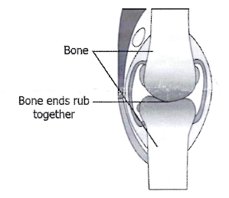
Which connective tissue can likely be added between the bones to ease the movement of joints?
(a) blood as it contains proteins (b) areolar tissue as it repairs the tissue
(c) ligament as it joins the two bones easily (d) cartilage as it smoothens surface of the bones
- Which of the following statements is incorrect?
(a) Blood has matrix containing salts, proteins and hormones.
(b) Two bones are connected with ligaments.
(c) Tendons are non-fibrous tissue and are fragile.
(d) Cartilage is a form of connective tissue.
- The crossing between two plants with different desired characters in order to combine these Characters is called …………….
(a) natural selection (b) intercropping
(c) hybridisation (d) mixed cropping
- Which one of the following fishes is a surface feeder?
(a) Rohus (b) Mrigals (c) Common carps (d) Catlas
- A soil sample has adequate water holding capacity but is deficient in phosphorous and potassium.
Which of these would improve the quality of crops grown in that field?
(a) Removing weeds (b) Applying fertilisers (c) Modifying irrigation system
(d) Growing two different crops at the same time
Q 17 to 20 consists of two statements - Assertion (A) and Reason (R). Answer these questions selecting the appropriate option given below:
(a) Both (A) and (R) are true and (R) is the correct explanation of (A).
(b) Both (A) and (R) are true and (R) is not the correct explanation of (A).
(c) (A) is true but (R) is false
(d) (A) is false but (R) is true
- Assertion: If the net external force on the body is zero, then its acceleration is zero.
Reason: Acceleration does not depend on force.
- Assertion: The endoplasmic reticulum which lacks ribosomes is called smooth endoplasmic reticulum (SER).
Reason: SER is mainly involved in protein synthesis.
- Assertion: According to law of conservation of mechanical energy, change in potential energy is equal and opposite to the change in kinetic energy.
Reason: Mechanical energy is not a conserved quantity.
- Assertion: The squamous epithelium is made of a single layer of flattened cells with irregular boundaries.
Reason: They are found in walls of blood vessels.
SECTION-B
Question No. 21 to 26 are Very Short Answer Type Questions
- Classify the following into elements and compounds.
(i) Sodium (ii) Calcium carbonate (iii) Tin (iv) Table salt
- Write down the formulae of
(i) Sodium oxide (ii) Aluminium chloride
(iii) Sodium sulphide (iv) Magnesium hydroxide
- Attempt either option A or B
A. What were the limitations of J.J. Thomson's model of the atom?
OR
B. What are isotopes? Write two uses of isotopes.
- A pair of bullocks exerts a force of 140 N on a plough. The field being ploughed is 15 m long.
How much work is done in ploughing the length of the field?
- Attempt either option A or B
Give reasons for the following:
A. The reverberation time of a hall used for speeches should be very short.
OR
B. A vibrating body produces sound. However, no sound is heard when a simple pendulum oscillates in air.
- Give one point each of difference and similarity between mitochondria and plastids.
SECTION-C
Question No. 27 to 33 are Short Answer Type Questions
- Give two examples each of true solution, colloid and suspension.
- Attempt either option A or B
A. Derive an expression for acceleration due to gravity in terms of mass of the earth (M) and universal
gravitational constant (G).
B. A stone dropped from the roof of a building takes 4s to reach the ground. Calculate the height of the building.
OR
- A ball of mass 2 kg is thrown up with a speed of 10m/s. Find the kinetic energy of the ball at the 'time of throwing. Also, find the potential energy of the ball at the highest point.
- What is ultrasound? Explain two applications of the ultrasound.
- Draw a plant cell and label the parts which:
(i) determines the function and development of the cell
(ii) packages materials coming from the endoplasmic reticulum
(iii) provides resistance to microbes to withstand hypotonic external media without bursting
(iv) is site for many biochemical reactions necessary to sustain life
(v) is a fluid contained inside the nucleus
(vi) are thread like structures which are responsible for inheritance of characters
- Attempt either option A or B
A. Draw a neat labelled diagram of a plant and mark the following meristems:
(i) Apical meristem (ii) Lateral meristem (iii) Intercalary meristem
State the function of each type of meristem.
OR
B. Give reasons why:
(i) We get a crunchy and granular feeling when we chew pear fruit.
(ii) Branches of a tree move and bend freely in high wind velocity.
(iii) It is difficult to pull out the husk of a coconut tree.
- What is genetic manipulation? How is it useful in agricultural practices?
SECTION-D
Question No. 34 to 36 are Long Answer Type Questions
- Attempt either option A or B
A. i. The electronic configuration of phosphorus atom is 2, 8, 5. Give the electronic configuration of P3 ion.
ii An element "X" contains 6 electrons in "M" shell as valence electrons:
(a) What is the atomic number of "X"?
(b) Identify whether "X" is a metal or non-metal.
iii. Give reason
(a) An atom is electrically neutral.
(b) Helium atom has zero valency.
OR
B. The given figure depicts the atomic structure of an atom of an element “X”. Write the following information about the element "X".
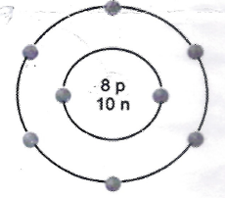
(a) Atomic number of "X" (b) Mass number of "X"
(c) Number of Valence electrons (d) Valency of "X" 2
(e) Identity whether "X" is a metal or non-metal.
- Attempt either option A or B
A. (i) State Newton's second law of motion.
(ii) The velocity-time graph of a ball moving on the surface of floor is shown in the figure. Calculate the force acting on the ball, if mass of the ball is 100 g.
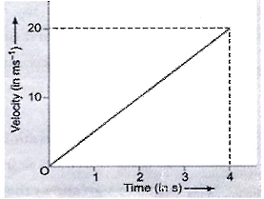
OR
B. i. If both mass and force acting on a body are doubled, what happens to its acceleration?
ii. If action is always equal and opposite to reaction, then why don't they cancel out each other?
iii. Why do you fall in the forward direction when a moving bus brakes to a stop and fall backwards when it accelerates from rest?
- Attempt either option A or B
A. i. Explain the structure of the neuron with the help of well labelled diagram.
ii. Give two differences between Xylem and Phloem.
OR
B. Give one function of each of the following:
(i) Tendons (ii) Ligament (iii) Adipose tissue (iv) Cartilage (v) Blood
SECTION – E
Question No. 37 to 39 are Case - Based/Data- Based Questions.
- Hydrogen and oxygen combine with each other to produce water. When 1 g of hydrogen reacts with 8 g of oxygen, 9 g of water is always produced.
A. Which laws of chemical combination are governed here? Justify your answer.
Attempt either sub-part B or C
B. Write the ratio by number of atoms of hydrogen and oxygen in a molecule of water.
OR
C. How would you confirm that a colourless liquid given to you is pure water?
- Pallavi Ma'am was demonstrating an experiment in her class with the setup as shown in the figure
below. She took an eraser, sharpener, steel spoon, plastic ruler, pencil, compass and rubber band and
asked the students to place them on the surface of the water. Students observed that a few objects
float on the surface of water while a few sink in water.
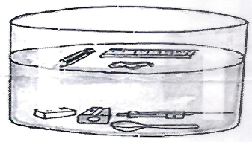
Attempt either sub-part A or B
A. How does an object float in liquid?
OR
B. Why does an object sink in liquid?
C. In which direction does the buoyant force act on an object immersed in a liquid?
D. On what factor does the magnitude of buoyant force depends?
E. State the Archimedes' principle.
- Ms. Sharma gave the following instructions to her students to carry out the following osmosis experiment.
Take four peeled potato halves and scoop each one out to make potato cups. One of these potato cups should be made from a boiled potato. Put each potato cup in a trough containing water.
(a) Keep cup A empty. (b) Put one teaspoon sugar in cup B.
(c) Put one teaspoon salt in cup C. (d) Put one teaspoon sugar in the boiled potato cup D.
(e) Keep these for two hours. Then observe the four potato cups.
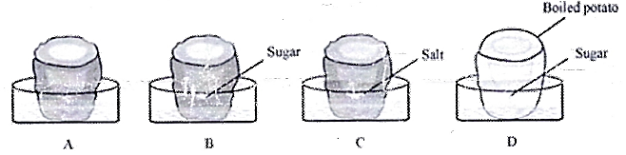
Based on the experiment stated above, answer the following –
A. A student claimed that endosmosis takes place in the hollowed portion of B and C. Is the claim correct?
B. Why water does not gather in the hollowed out portion of cup 'D?'
Attempt either sub-part C or D
C. Give two points of differences between osmosis and diffusion.
OR
D. State any two examples of 'Osmosis' from real life.

1. Matter in Our Surroundings
(No direct questions found for this chapter)

2. Is Matter Around Us Pure?
- A student is asked to make a homogeneous mixture…
- Which of the following will show the "Tyndall effect"?
- Which of the following are chemical changes?
- Classify the following into elements and compounds.
- Give two examples each of true solution, colloid and suspension.

3. Atoms and Molecules
- Two substances, A and B, react to form a third substance...
- Write down the formulae of...
- Hydrogen and oxygen combine...

4. Structure of the Atom
- Two atoms are said to be isotopes if…
- Which of the following does not represent Bohr's model of an atom...
- Select the correct relation between atomic number, mass number...
- Option B - What are isotopes? Write two uses of isotopes.
- Both options A and B (about atomic structure and configuration)

5. Motion
(No direct questions found for this chapter)

6. Force and Laws of Motion
- A goalkeeper in a football game pulls his hands backwards...
- Assertion and Reason on Newton's laws.
- Both options A and B (Newton’s laws, velocity-time graph, action-reaction)

7. Gravitation
- Case-based question on floating and sinking (Archimedes’ principle, buoyant force)
- Option A - Derive expression for acceleration due to gravity.

8. Work and Energy
- A mass is moving with a speed of 5m/s…
- A pair of bullocks exerts a force…
- A ball of mass 2 kg is thrown up...
- Assertion and Reason on mechanical energy conservation.

9. Sound
- When a body vibrates, it compresses the surrounding air…
- Option A - Reverberation time…
- What is ultrasound? Explain two applications...

10. The Fundamental Unit of Life
- In summer, the leaves of a potted plant droop…
- Assertion and Reason on endoplasmic reticulum.
- Draw a plant cell and label...
- Case-based question on potato osmosis experiment.

11. Tissues
- A student observes image of the knee bones...
- Which of the following statements is incorrect?
- Assertion and Reason on squamous epithelium.
- Both options A and B (meristematic tissues and anatomical structures)
- Option A – Structure of neuron, xylem and phloem
- Option B – Functions of various connective tissues

12. Why Do We Fall Ill?
(No direct questions found for this chapter)

13. Improvement in Food Resources
- The crossing between two plants...
- Which one of the following fishes is a surface feeder?
- A soil sample has adequate water holding capacity…
- What is genetic manipulation? How is it useful...

